**Bugs List(On 16-12-24):**

**USERS SCREEN:**

1. Add New-Status value should always display “Active” and remove please select option in the dropdown.
2. Add New-Tool tip details are not displayed in project mapping tab.
3. Add New-Time take for Save functionality more than 5 secs.
4. Add New-After enter valid details and click clear button, project mapping details is not cleared.
5. Edit-After click clear button, last modified by details displayed wrong details.
6. Edit-Need to change the “Change Email” button and place it below right corner of the email tab and give underline for the button text.
7. After create a user and after login with same user details , in profile displayed wrong values.

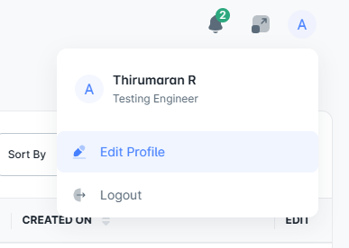

1. After create a user with newyork time and after login with the same user, in users grid time details are displayed according with INDIAN location.
2. In profile button, profile image is not displayed.
3. In users, when try to search the email id, grid displayed empty values.
4. In users, when try to Go to next page via GO TO button in left bottom corner, the 2nd page grid shows empty but it need to show “No data found” message.
5. In users, when the user is in “Inactive” status and try to login with same user details, the message should show “Your account has been locked, please contact admin for further”.
6. Edit-After click change password button, tab only highlight the “Personal Information” tab only but it need to highlight inn “Change Password” tab.
7. Edit-After click change password button, Need to add the password requirement text details in the page.
8. Edit-After click change password button, after enter valid password details and click clear button, details are cleared. Once mouse hover to the new and confirm password tab, previously entered details are automatically displayed.
9. Edit-After click change password button, after enter valid new and confirm password and click save button, “old and new password are same” message is displayed.
10. After create a user, in login page, after click forget password button and when click “Ok, Got It” button loading symbol displayed diffrently.

**TEAM:**

1. Background image is not clear.
2. When mouse hover to the create team button, text is not properly displayed.
3. Create Team- Predefined text has more space.

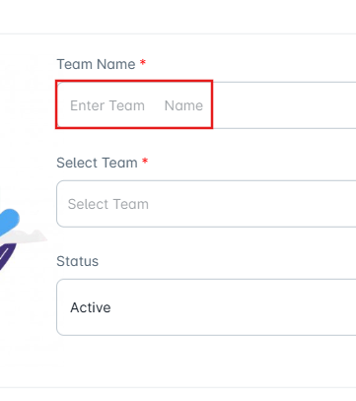

1. Create Team- without enter the team name and select the team names and now enter the team name, selected team details are removed.
2. Create Team- After enter valid team name and select team deails and when try to change the status, selected team details are removed.
3. After create a team, edit and delete alignement is not proper.

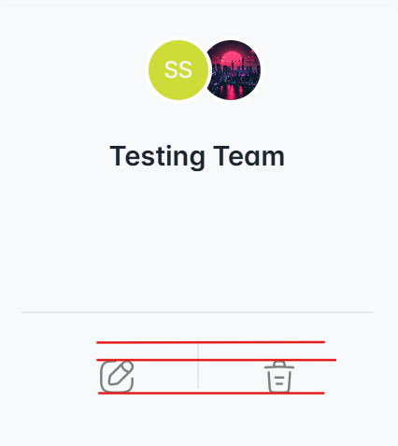

1. Edit team- Created user with newyork time but last modified date displayed INDIAN location time.
2. Edit Team-After change the team to inactive status, team is hidden from the page.

**SCREEN RIGHTS:**

1. Last modified date shows “Null” details.
2. Created user with newyork time but last modified date displayed INDIAN location time.
3. Change initial letter of the kanban board spelling to be Uppercase.
4. Need reasons from the lead for multiple screens in a single checkbox (Kanban board, TimeLine, Dashboard, Budget)